Mission Statement

Clear Skies is committed to providing high quality, client-centered Residential Child and Youth services to its clients to assist them to lead dignified and independent lives in a safe and structured home life setting. Their individual needs are carefully assessed, understood and met through the selective assignment of qualified, trustworthy and compassionate personnel.

Who we are

Clear Skies Community Care Services was incorporated in 2015 and since then has been providing 24-hour residential care for children / youth between the ages of 6 and 19 who are in need of a long term structured residential program. Clear Skies Community Care Services serves the Surrey and Delta area and will address the child’s/ youth’s individual mental health, social, behavioral, and emotional needs. It is a referral-based program and all referrals come from MCFD.

Our Goal

Clear Skies Community Care Services overall purpose is to provide residential care and support for children and youth in order to increase stability. With creating a safe and encouraging environment our focus includes:

*Providing quality residential care services
*Providing opportunities for personal growth
*Transitioning Children / Youth back into the family home
*Preparing the children / youth with life skills and programming necessary to transition into independence

Our Philosophy

The whole PHILOSOPHY is based on the belief that everyone has the potential to manage their behaviors. This is accomplished by providing a consistent, caring, and structured routine. The underlying premise of our philosophy is that we meet the client where they are at and ensure that they are part of their care plan.

*We believe in respecting the dignity and diversity of our clients, staff, and stakeholders.
*We are committed to providing excellence in our client service
*We believe that all people have the right to be included in decisions that affect them
*We believe in respecting all client rights and abiding by Clear Skies code of ethics.

Program Description

Clear Skies Community Care Services is a home-like environment where staff will collaborate with professionals in the community to create a strength-based person-centered plan that will meet the individual needs of the child / youth. These plans will enable the child / youth to develop the skills needed to have a better quality of life. These include creating opportunities for positive social interaction and improving relationships with natural support systems, encouraging education, teaching life skills, increasing coping strategies needed for emotional / behavioral regulation, address any health-related needs, and foster identity, cultural and religious exploration.
The residences are a 24-hour staffed resource where a child / youth reside with Resident care workers. The Residential Resource Manager provides the child /youth with one-on-one individualized support and case manages the child /youth’s individualized service plan (ISP). In case of a crisis situation or when extra support is needed, the child /youth and staff have access to support 24 hour a day, seven days a week.

Our Approach

Clear Skies Community Care Services believes that every child / youth is unique and needs their own Individual Support Plan (ISP) as a guide to foster stability and personal growth. In collaboration with the child / youth and their care team, Clear Skies assesses the individual needs of the child / youth and creates specific ISP goals. Our service delivery approach builds a network of natural and professional supports, as well as community resources to assist the child /youth in obtaining their goals. The child /youth and their care teams are involved in Integrated Case Management (ICM) meetings, and we support the use of ICM practices within Clear Skies services. Clear Skies creates a consistent and structured home-like environment with the focus on building relationships and creating opportunities for self-development within the home.

- To provide the physical, social, and emotional care of Clear Skies residents in a manner that closely models the training and expectations of a family home.
- To provide residents with experience in learning regular and normal habits of personal hygiene and self-care.
- Provide leisure time and learning experiences that will help each resident to you such time in a socially constructive manner.
- To design a program that will assist the resident in identifying issues and maladaptive behaviors in an effort to work towards socially appropriate behaviors while interacting with peers, family and the community.
- To assist the Clear Skies residents who are involved in regular or alternate educational programs in functioning effectively, as well as assisting those working towards being gainfully employed and independent.
- To assist Clear Skies residents in planning for their future with family, foster home or independent living.
- And lastly but not least, to provide a monitored living situation that will adhere to all specific outlines and probation orders (for example curfews, restricted contacts, etc.).

Our Staff

Clear Skies Community Care Services consists of 25 experienced professionals with expertise in a wide variety of disciplines. The Director, Human Resource Manager, Residential Resource Managers and Residential Support Workers are what brings our agency to life. We encourage our staff team to be creative, flexible, and efficient in the development and delivery of programs and services that enhance our client’s lives.

The following outlines the service delivery improvement plan for Clear Skies Community Care Services. The purpose of the plan is to guide the collection of performance data on the service that Clear Skies Community Care Services delivers and to support ongoing quality improvement.

QUALITY IMPROVEMENT CYCLE

Clear Skies Community Care Services Inc improvement process is based on the Deminng cycle. The process is outlined below. 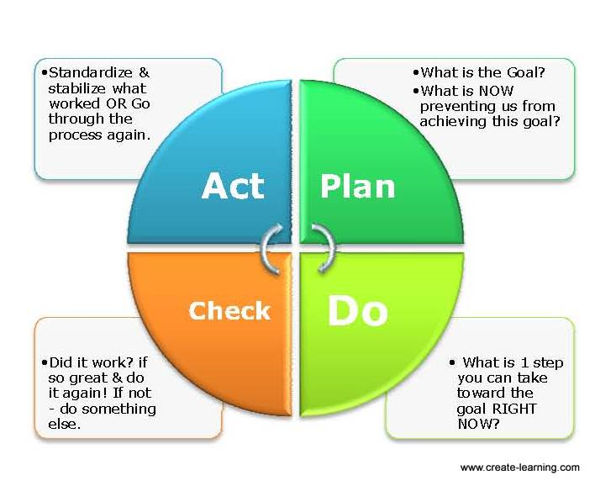

PLANNING & DOING – DEFINING OUTCOMES TO BE ACHIEVED

Program Efficiency: Efficiency measures the resources used to deliver service. Clear Skies Community Care Service’s Inc. utilizes the measurement of staff training compliance in order to ensure the highest quality of services is provided to each unique client.

Program Effectiveness: Effective measures address the quality of care through measuring change over time. Clear Skies Community Care Services Inc. utilizes the measurement of improvement with the client’s symptomatic / and or asymptomatic behaviors, and the level of engagement and participation with daily living activities.

Program Access: Outcomes are intended to look at how accessible the agency’s program or services are to the person being served. As it relates to service delivery, Clear Skies Community care services measures the number of days from referral to admission.

Feedback: Refers to information gathered from persons served and other stakeholders about the quality of services provided by Clear Skies Community Care Services Inc. The agency gathers feedback through surveys of the children / youth serviced and other / stakeholders.

Participant Demographics & Program Utilization

Total Number of Children / Youth served in 2021: 9
Number of New Admissions: 2
Average Age of the Child / Youth at Admission: 12 years
Number of Referrals: 2
Transitioned and or Adult: 1

Participants in Survey Results – 8 for 2021

GENDER | RACE | AGE GROUP | TIME IN PROGRAM
Male: 6 | Caucasian: 3 | 11 and under: 3 | Less than 3 months: 0
Female: 1 | Asian: 1 | 12-17 years: 4 | 3-5 months: 2
Other: 1 | Indigenous: 4 | 18-21 years: 1 | 2 years plus: 6
Total: 8

Criminal Involvement:0
School / Education: 0
Physical Health: 0
Mental Health: 8
Vocational Rehabilitation: 0
Other:0

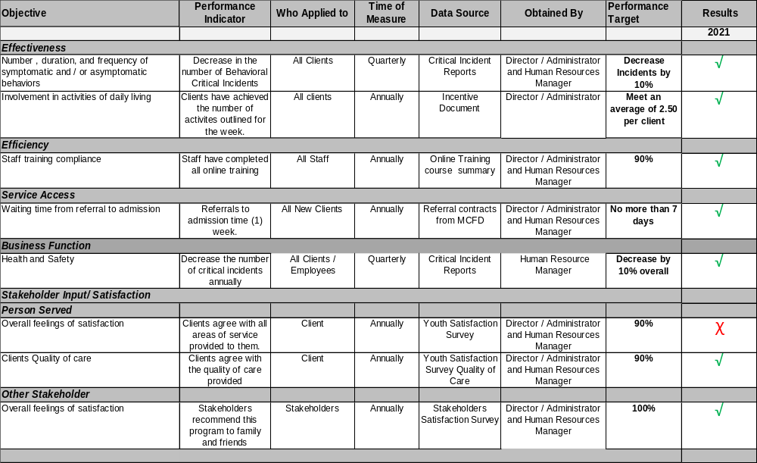

Discussion & Action Plan

- In 2021 the “Effectiveness” measure was met, the number of critical incident reports generated by symptomatic behaviors were 11 versus 33 in 2020. Clear Skies will continue to incorporate strategies to meet the individuals needs that focus on reducing the number of “behavioral” incidents.

- In 2021 the “Effectiveness”, we measured 7 client’s Involvement in activities of daily living. This goal was achieved by six of the seven clients in 2021. We will continue to incorporate strategies for individualized incentive plans for each client throughout 2022.

- In 2021 the Efficiency measure; Staff Training Compliance was met with 100% compliance. We will continue to provide additional training in specific areas based on the needs of each individual client.

- Service Access: Wait time from referral to admission was met with each client. The goal for the agency was a 7-day timeframe. In 2021 there were two new admissions into the organization. Survey results from other / stakeholders decreased to 70% in 2021 versus 78.12 in 2020. This is an area the company continues to focus on for 2022 in meeting our goal of 7 days with any new admissions.

- The Business Function- Health and Safety: In 2021 the company did meet their goal of decreasing the number of critical incidents overall. In 2021 Clear Skies reported 29 incidents versus 54 in 2020. Our focus is on Self Injurious Behaviors, property damage, assaultive behavior, and injury to staff and or client. Clear Skies will continue to set program goals to target further reductions in critical incident reports.

Strategies / Activities / Tasks

Clear Skies will provide staff with professional development opportunities including training on FASD, Autism and Schizophrenia. | Director / Administrator & Human Resource Manager | January - December 2021 – completed.  Ongoing focus for 2022 with new hires and existing employees.
Clear Skies will create unique Incentive plans that better reflect the strengths and abilities of the clients. | Director / Administrator / Residential Resource Managers. | 2021 – completed  for all Clients and will continue throughout 2022.
Clear Skies will continue to work closely with MCFD and the clients care team to reduce the waiting time for admission. | Director / Administrator / Residential Resource Managers. | Ongoing focus for 2022 for any new admissions.
Clear Skies will continue to work with staff to strategize on symptomatic behavioral incidents with individuals. | Director / Administrator / Residential Resource Managers. | Ongoing focus for 2022

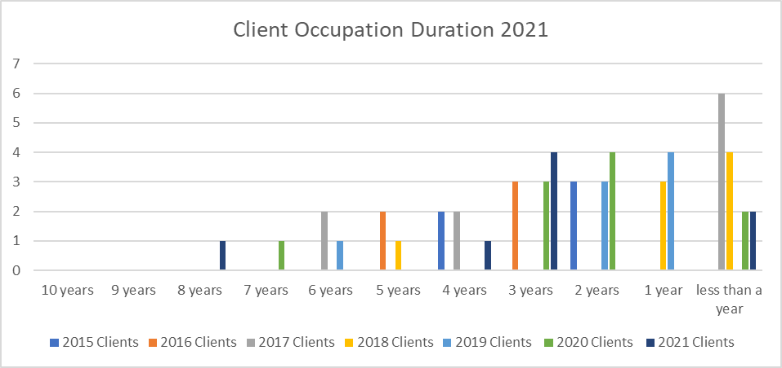

Yearly Outcome Trending
Clear Skies Community Care Services Inc. Occupant Duration 2015 /2016 / 2017 /2018 / 2019 / 2020/2021.

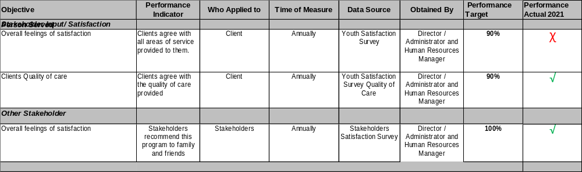

Discussion & Action Plan

- At the end of December 2021, we invited the (8) children / youth clients to participate in the satisfaction survey. We received (8 ) completed satisfaction surveys compared to (6) in 2020.

- Comparison to survey satisfaction results from Children / Youth participants in 2021 & 2020. We see a decrease of satisfaction in the areas of Cultural Competency, 92.6% versus 100% in 2020.

- The level of satisfaction in the category of Health and Safety increased in 2021, 97.6 % versus 93.2% in 2020.

- The areas of opportunity identified is in Treatment and Planning, this is a continuing focus for 2022.

Strategies / Activities / Tasks
Clear skies will promote the Company’s Website as a tool to obtain more surveys from Other / stakeholders and Children / Youth. | Director / Administrator / Resource Managers | Ongoing focus for 2022  In 2021 there was a total of 36,382 visits to the website.
Continue to meet with clients to get input and feedback on how to improve Quality of Life, “My overall quality of Life has improved since beginning services” and “My personal relationships, family relationships and or support system dynamic has improved”. | Director / Administrator / Resource Managers and Employees | We did not meet this target at 95.2% but did see an increase of satisfaction versus 93.4% last year.
Clear Skies will work closely with MCFD and the clients care team to close the gap on referral to admission time. | Director / Administrator | There were two new admissions in 2021, however this continues to be a focus for 2022.

Annual Review of Formal Complaints

Q1 Complaints Received | Q2 Complaints Received | Q3 Complaints Received | Q4 Complaints Received | % Complaints Resolved | % Complaints Unresolved | Goal | Meet or Exceed Goal
0 | 0 | 0 | 0 | 0 | 0 | 0 | Did Meet Goal

