Mission Statement

Clear Skies is committed to providing high quality, client-centered Residential Child and Youth services to its clients to assist them to lead dignified and independent lives in a safe and structured home life setting. Their individual needs are carefully assessed, understood and met through the selective assignment of qualified, trustworthy and compassionate personnel.

Who we are

Clear Skies Community Care Services was incorporated in 2015 and since then has been providing 24-hour residential care for children / youth between the ages of 8 and 19 who are in need of a long term structured residential program. Clear Skies Community Care Services serves the Surrey / Delta area and will address the child’s/ youth’s individual mental health, social, behavioral, and emotional needs. It is a referral based program and all referrals come from MCFD.

Our Goal

Clear Skies Community Care Services overall purpose is to provide residential care and support for children and youth in order to increase stability. With creating a safe and encouraging environment our focus includes:

*Providing quality residential care services
*Providing opportunities for personal growth
*Transitioning Children / Youth back into the family home
*Preparing the children / youth with life skills and programming necessary to transition into independence

Our Philosophy

*We believe in respecting the dignity and diversity of our clients, staff, and stakeholders.
*We are committed to providing excellence in our client service
*We believe that all people have the right to be included in decisions that affect them
*We believe in respecting all client rights and abiding by Clear Skies code of ethics.

Program Description

Clear Skies Community Care Services is a home-like environment where staff will collaborate with professionals in the community to create a strength based person centered plan that will meet the individual needs of the child / youth. These plans will enable the child / youth to develop the skills needed to have a better quality of life. These include creating opportunities for positive social interaction and improving relationships with natural support systems, encouraging education, teaching life skills, increasing coping strategies needed for emotional / behavioral regulation, address any health-related needs, and foster identity, cultural and religious exploration.
The residences are a 24-hour staffed resource where a child / youth reside with Resident support workers. The house coordinator provides the child /youth with one on one individualized support and case manages the child /youth’s individualized service plan (ISP). In case of a crisis situation or when extra support is needed, the child /youth and staff have access to support 24 hour a day, seven days a week.

Our Approach

Clear Skies Community Care Services believes that every child / youth is unique and needs their own Individual Support Plan (ISP) as a guide to foster stability and personal growth. In collaboration with the child / youth and their care team, Clear Skies assesses the individual needs of the child / youth and creates specific ISP goals. Our service delivery approach builds a network of natural and professional supports, as well as community resources to assist the child /youth in obtaining their goals. The child /youth and their care teams are involved in Integrated Case Management (ICM) meetings and we support the use of ICM practices within Clear Skies services. Clear Skies creates a consistent and structured home-like environment with the focus on building relationships and creating opportunities for self-development within the home.

Our Staff

Clear Skies Community Care Services consists of 14 experienced professionals with expertise in a wide variety of disciplines. The Director, resident coordinators and residential support workers are what brings our agency to life. We encourage our staff team to be creative, flexible, and efficient in the development and delivery of programs and services that enhance our client’s lives.

INTRODUCTION TO SERVICE DELIVERY IMPROVEMENT
The following outlines the service delivery improvement plan for Clear Skies Community Care Services. The purpose of the plan is to guide the collection of performance data on the service that Clear Skies Community Care Services delivers and to support ongoing quality improvement.

QUALITY IMPROVEMENT CYCLE

Clear Skies Community Care Services Inc improvement process is based on the Deminng cycle. The process is outlined below. 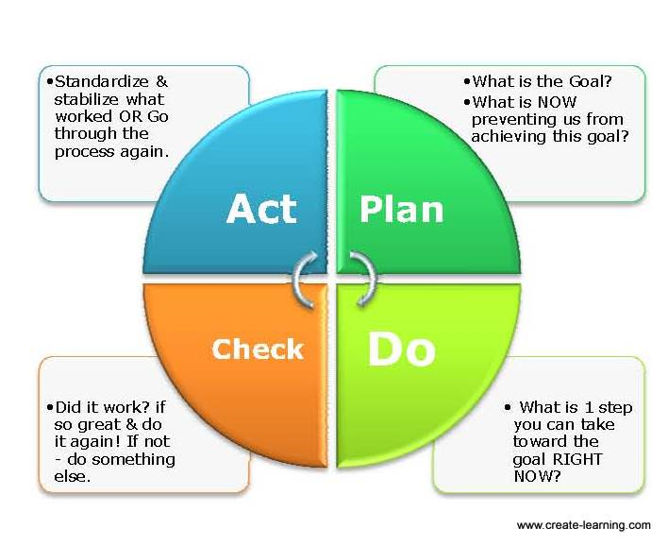

PLANNING & DOING – DEFINING OUTCOMES TO BE ACHIEVED

Program Efficiency: Efficiency measures the resources used to deliver service. Clear Skies Community Care Service’s Inc. utilizes the measurement of staff training compliance in order to ensure the highest quality of services is provided to each unique client.

Program Effectiveness: Effective measures address the quality of care through measuring change over time. Clear Skies Community Care Services Inc. utilizes the measurement of improvement with the client’s symptomatic / and or asymptomatic behaviors, and the level of engagement and participation with daily living activities.

Program Access: Outcomes are intended to look at how accessible the agency’s program or services are to the person being served. As it relates to service delivery, Clear Skies Community care services measures the number of days from referral to admission.

Feedback: Refers to information gathered from persons served and other stakeholders about the quality of services provided by Clear Skies Community Care Services Inc. The agency gathers feedback through surveys of the children / youth serviced and other / stakeholders.

Participant Demographics & Program Utilization

Total Number of Children / Youth served in 2016: 5
Number of New Admissions: 0
Average Age of the Child / Youth at Admission: 15 years
Number of Discharges / Referrals: 0

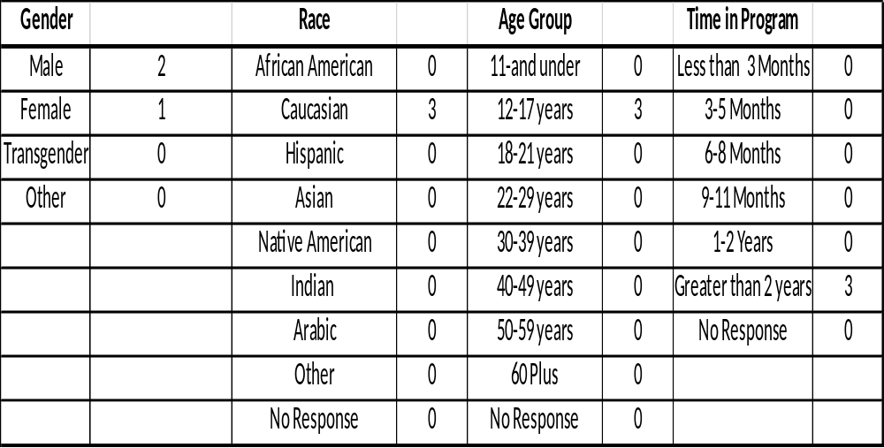

Client Demographics

Criminal Involvement:1
School / Education: 0
Physical Health: 0
Mental Health: 1
Vocational Rehabilitation: 0
Other:2

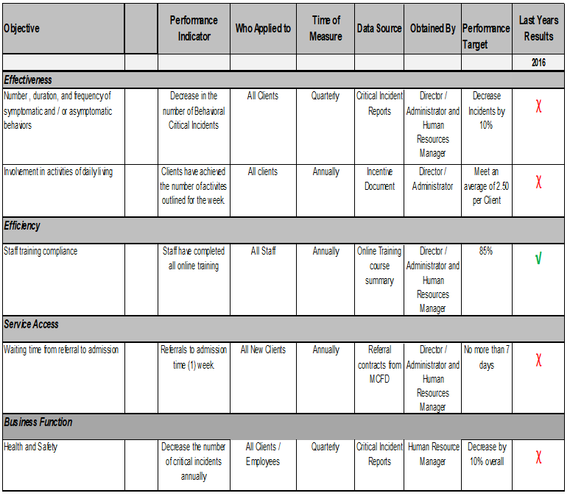

Discussion & Action Plan

- In 2016 the “Effectiveness” measure was not met, the number of critical incident reports generated by symptomatic behaviors were 6 versus 1 in 2015. Clear Skies will continue to incorporate strategies to meet the individuals needs that focus on reducing the number of “behavioral” incidents.

- In 2016 the “Effectiveness” we measured 3 client’s Involvement in activities of daily living. One out of the three clients exceeded the target of 2.50 average for the year. We will continue to incorporate strategies for individualized incentive plans for each client.

- In 2016 the Efficiency measure; Staff Training Compliance was met with 88% compliance. We will continue to provide additional training in specific areas based on the needs of each individual client.

- Service Access: Wait time from referral to admission was not met with each client. The goal for the agency was a 7-day timeframe. In 2016 survey results from the child / youth participants stated they were “satisfied that they got into the program quickly”, however survey results from other / stakeholders increased slightly from 55.56% in 2015 to 66.67 % in 2016 for the wait time. This is an area the company is focused on for 2017 in meeting our goal of 7 days.

- The Business Function- Health and Safety: In 2016 the company did not meet their goal of decreasing the number of critical incidents by 10%. In 2016 Clear Skies reported 28 incidents overall. Our focus is on property damage, assaultive behavior, and injury to staff and or client. Clear Skies will continue to set program goals to target further reductions in critical incident reports.

Strategies / Activities / Tasks

Clear Skies will provide staff with professional development opportunities including training on FASD, and Autism. | Director / Administrator & Human Resource Manager | September 2017
Clear Skies will create unique Incentive plans that better reflect the strength’s and abilities of the clients. | Director / Administrator / staff | May 2017
Clear Skies will continue to work closely with MCFD and the clients care team to reduce the waiting time for admission. | Director / Administrator | July 2017
Clear Skies will continue to work with staff to strategize on symptomatic behavioral incidents with individual clients. | Director / Administrator | September 2017

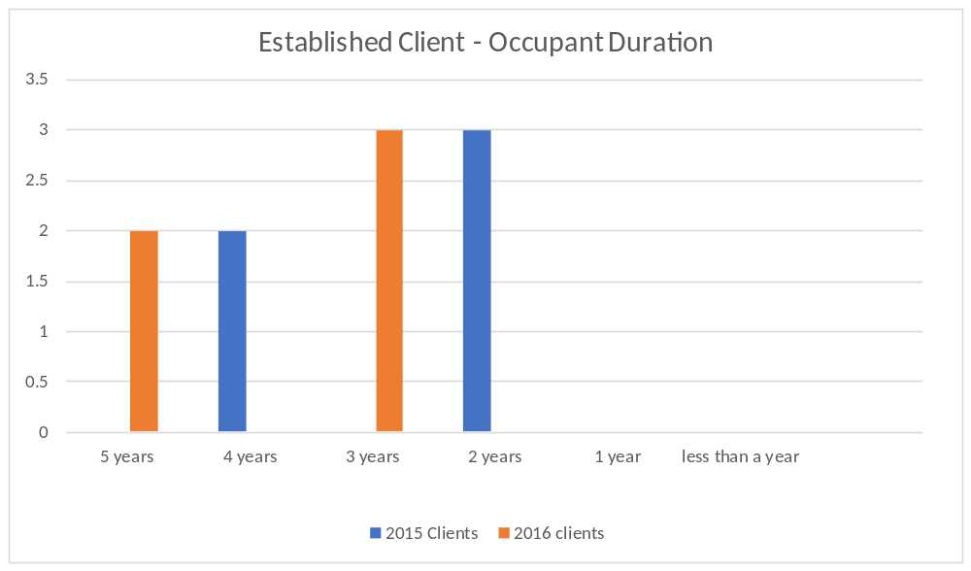
Yearly Outcome Trending
Clear Skies Community Care Services Inc. Occupant Duration 2015-2016.

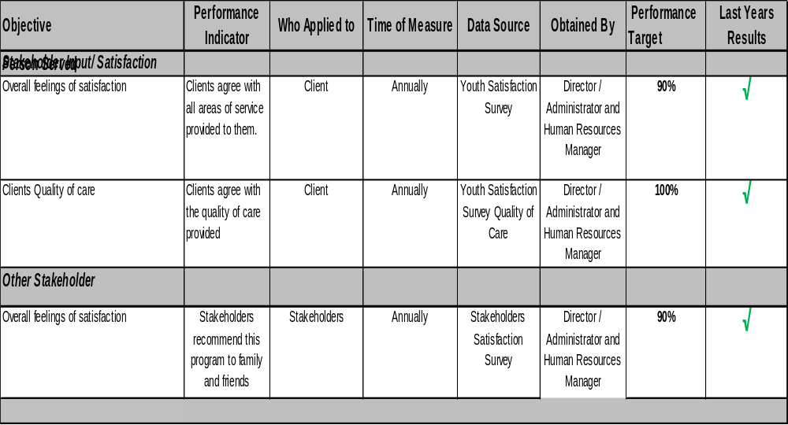

Discussion & Action Plan

- At the end of December 2016, we invited the (5) children / youth clients to participate in the satisfaction survey. We received 3 completed satisfaction surveys compared to (2) in 2015.

- Comparison to survey satisfaction results from Children / Youth participants in 2015 & 2016. We improved or remained the same in all areas of service. Areas of Improvements: Input, Rights, Assessment, Treatment Plan, Quality of Care, Cultural Sensitivity and Accessibility. We had no change in Quality of life which remained at 95%. This point within Quality of Life is - “doing better in school activities since starting the program”. This will be a focus in 2017.

- In 2016 Survey Participation from Other / Stakeholders was 6 versus 9 in 2015. One area in particular “Persons are admitted in a timely manner”, has a satisfaction rate of 66.67%. Although slightly higher than 55.56% in 2015 it is still an area of opportunity which we will continue to focus our efforts on in 2017.

Strategies / Activities / Tasks
Clear skies will promote the Company’s Website as a tool to obtain more surveys from Other / stakeholders and Children / Youth. | Director / Administrator | December 2017
Continue to meet with clients to get input and feedback on how to improve Quality of Life, in particular how the agency can assist better with education / school for the client. | Director / Administrator / Staff | June 2017
Clear Skies will work closely with MCFD and the clients care team to close the gap on referral to admission time. | Director / Administrator | September 2017

Annual Review of Formal Complaints

Q1 Complaints Received | Q2 Complaints Received | Q3 Complaints Received | Q4 Complaints Received | % Complaints Resolved | % Complaints Unresolved | Goal | Meet or Exceed Goal
0 | 0 | 0 | 0 | 0 | 0 | 100% | √

